1. <https://www.youtube.com/watch?v=QuNFQXj20dM&list=PLmCsXDGbJHdjcbrTz4myShv49zew0Umtg>
2. How to do Dependency Injection using Spring Expression Language SpEL(XML) | Spring Tutorial

  
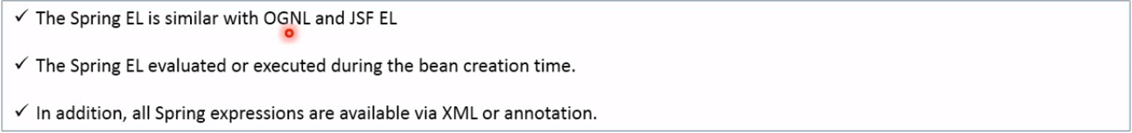

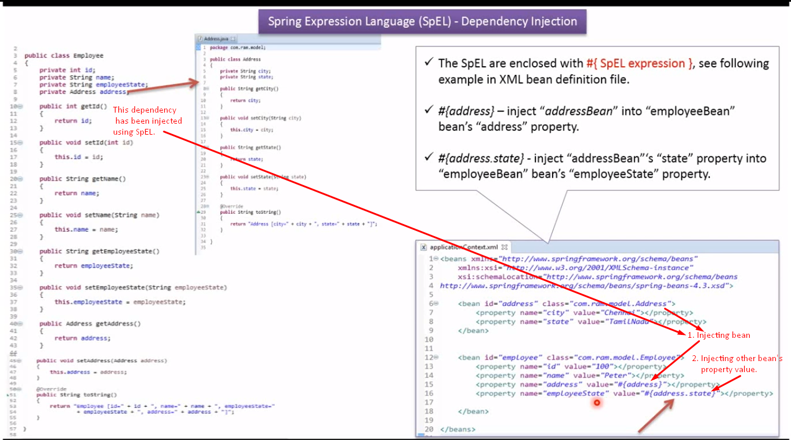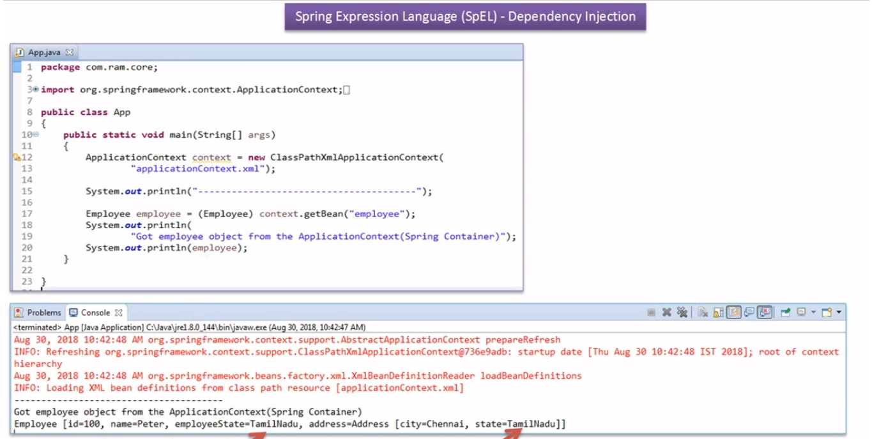

1. How to do Dependency Injection using Spring Expression Language SpEL(Annotation) | Spring Tutorial

In this video, we will convert Spring expression language using annotation.

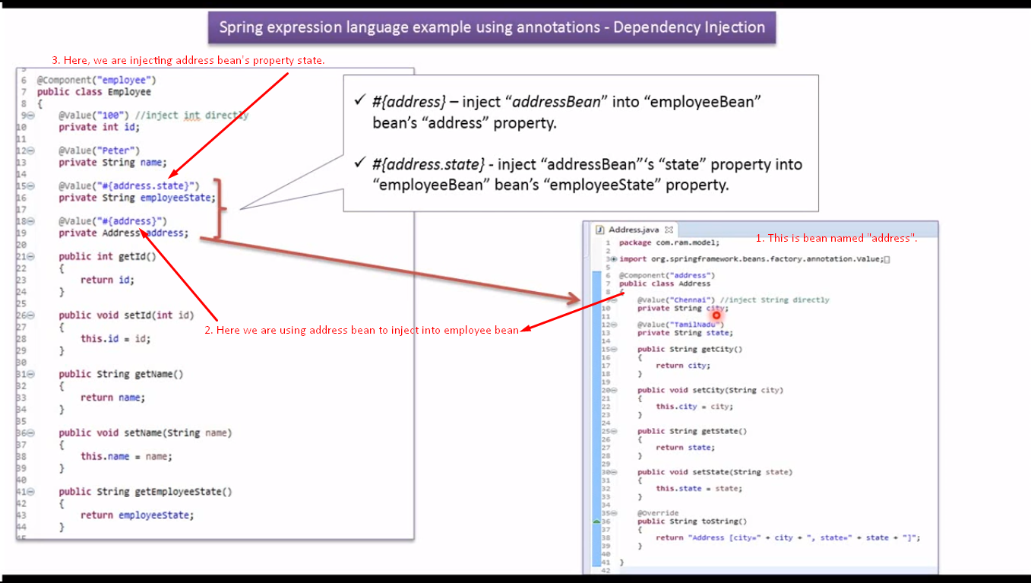

1. Bean reference example using spring expression language(XML) | Spring Tutorial

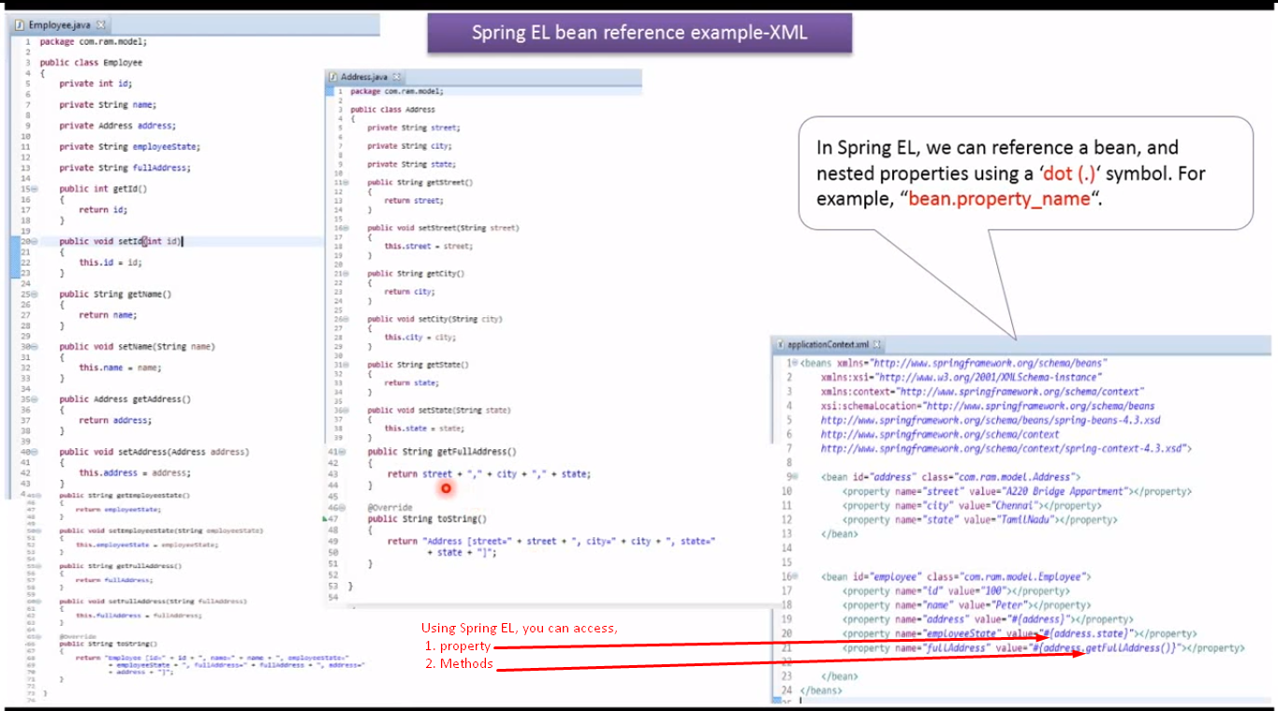

1. Bean reference example using spring expression language(Annotation) | Spring Tutorial

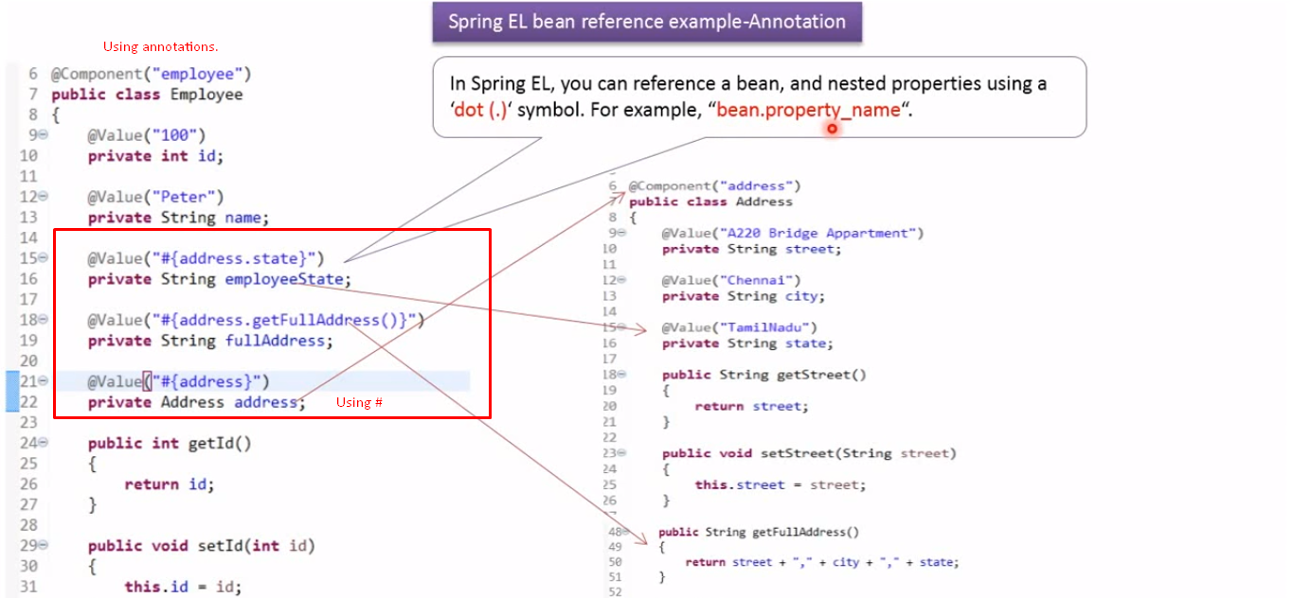

1. Spring expression language method invocation (XML) | Spring Tutorial | Spring Framework

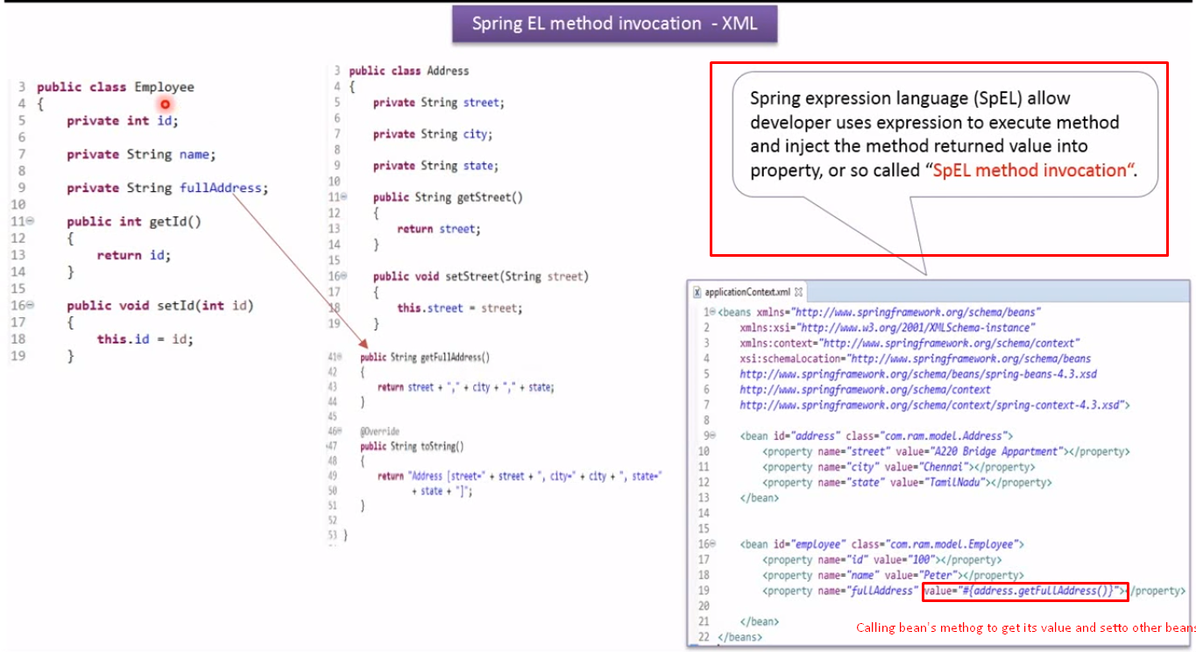

1. Spring expression language method invocation (Annotation) | Spring Tutorial | Spring Framework

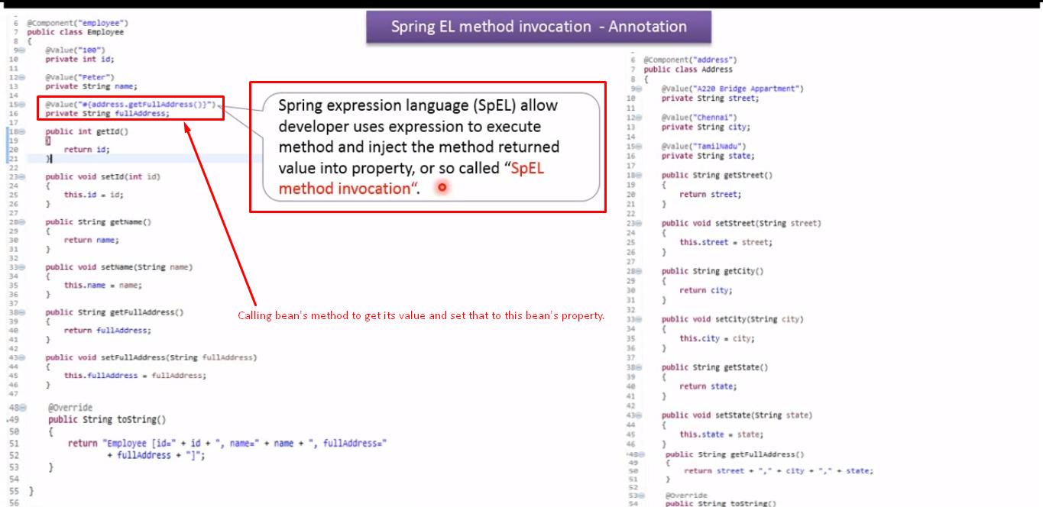

1. Spring expression language ternary operator (if-then-else) example [XML] | Spring Tutorial

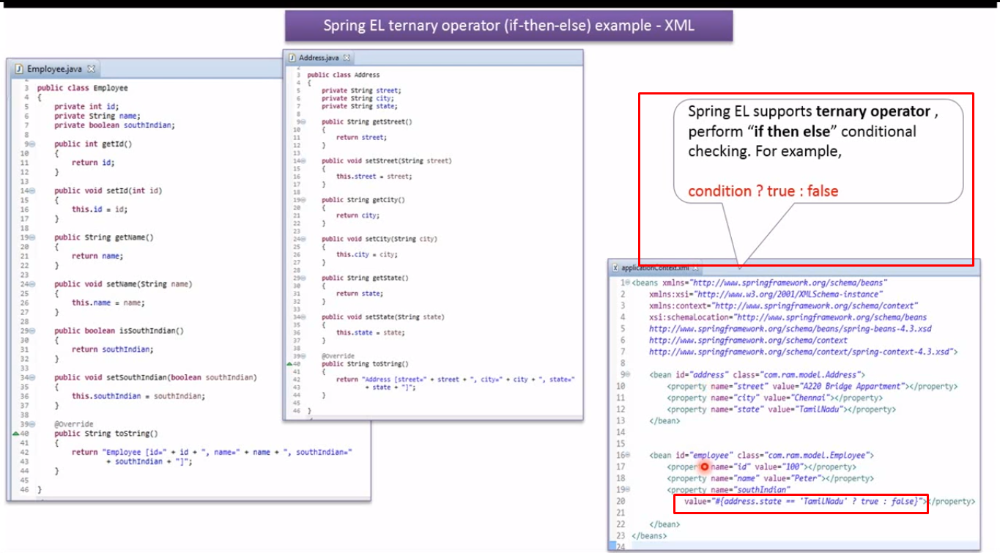

1. Spring expression language ternary operator (if-then-else) example [Annotation] | Spring Tutorial

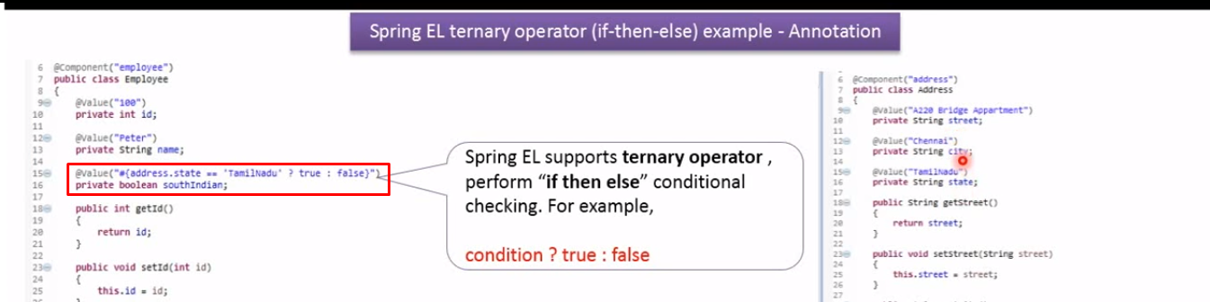

1. Relational operators in Spring Expression Language SpEL [XML] | Spring Tutorial

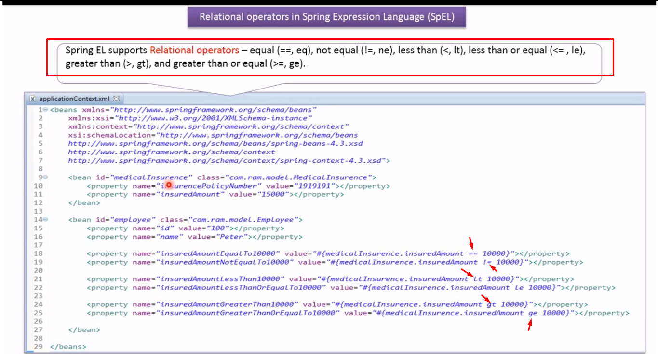

1. Relational operators in Spring Expression Language SpEL [Annotation] | Spring Tutorial

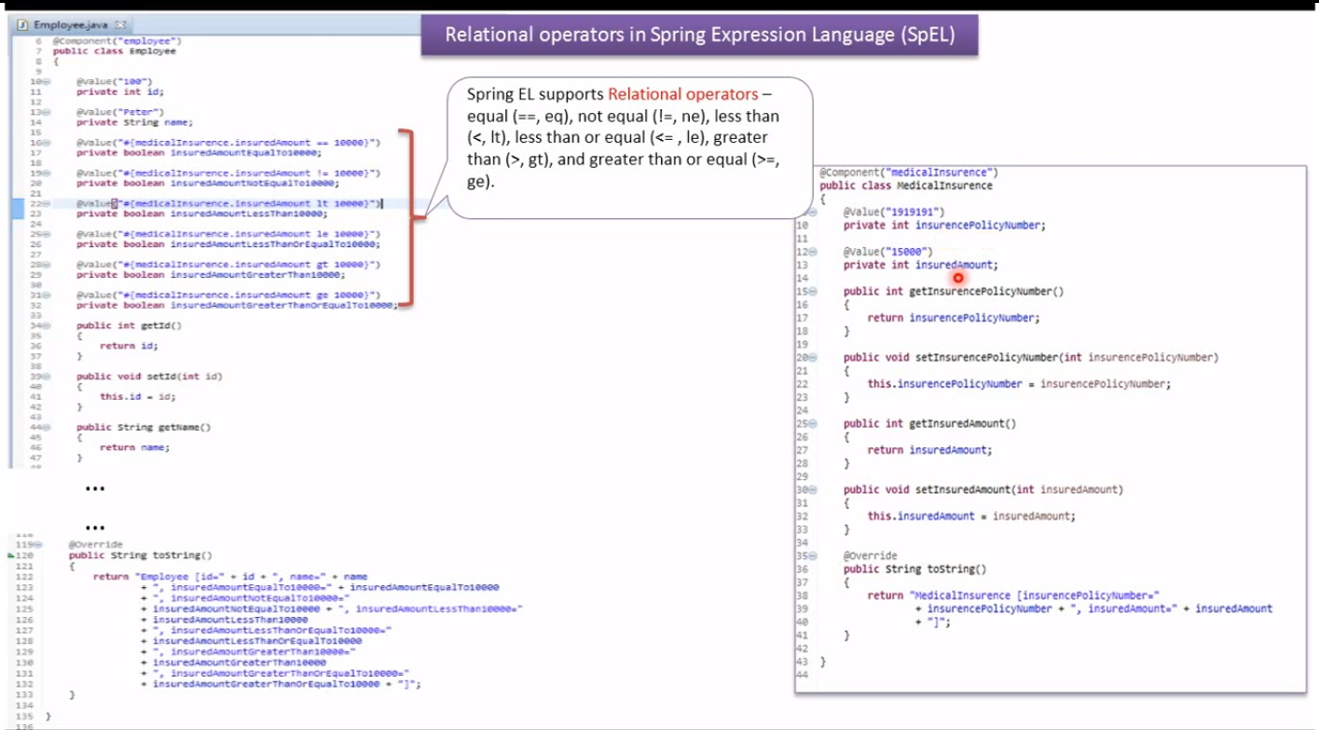

1. Logical operators in Spring Expression Language SpEL [XML] | Spring Tutorial

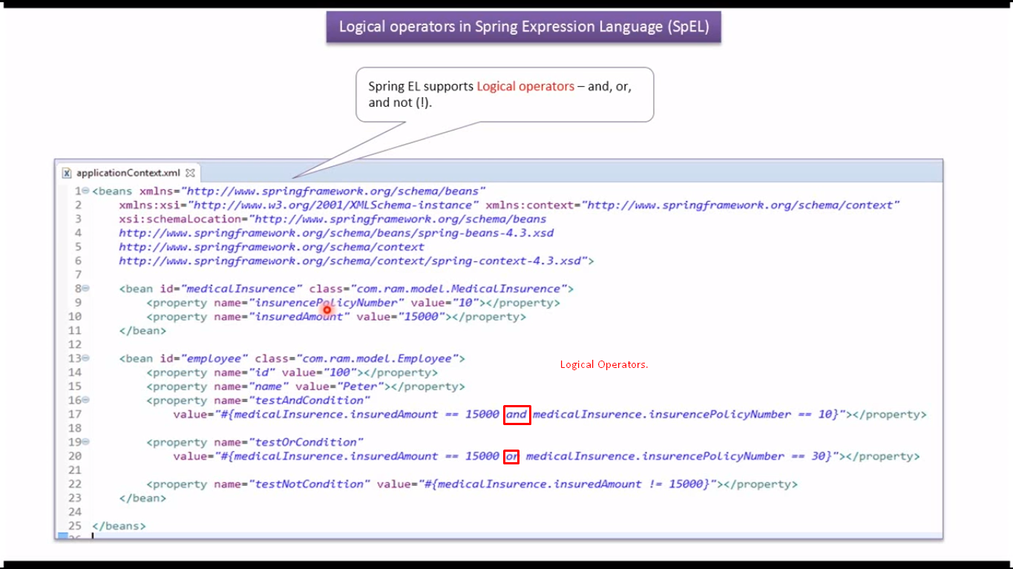

1. Logical operators in Spring Expression Language SpEL [Annotation] | Spring Tutorial

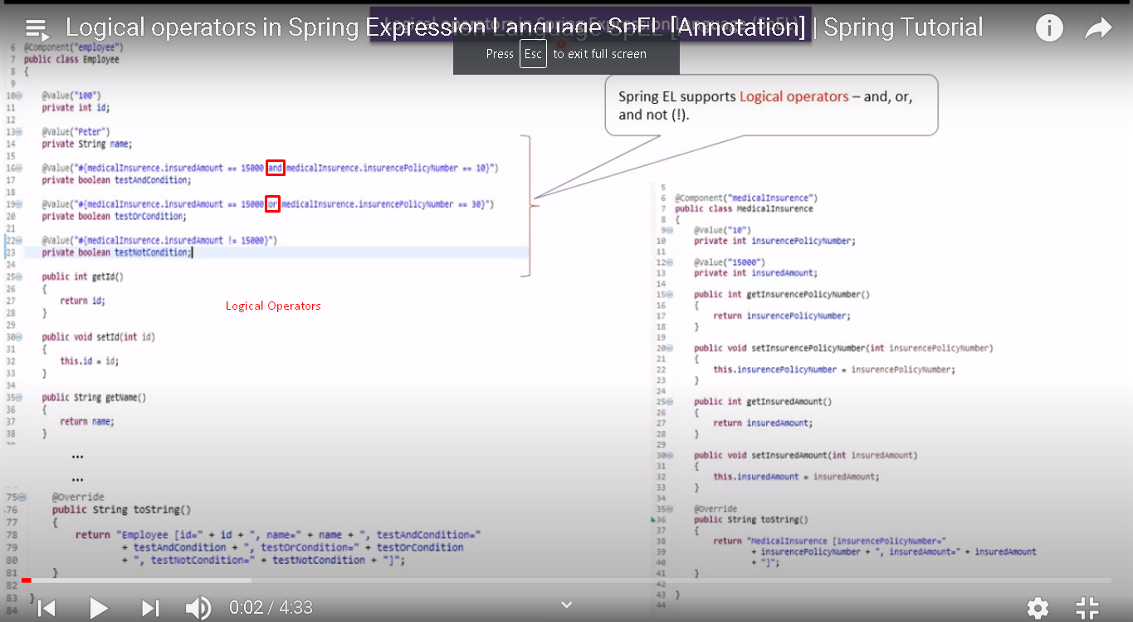

1. Mathematical operators in Spring Expression Language SpEL [XML] | Spring Tutorial

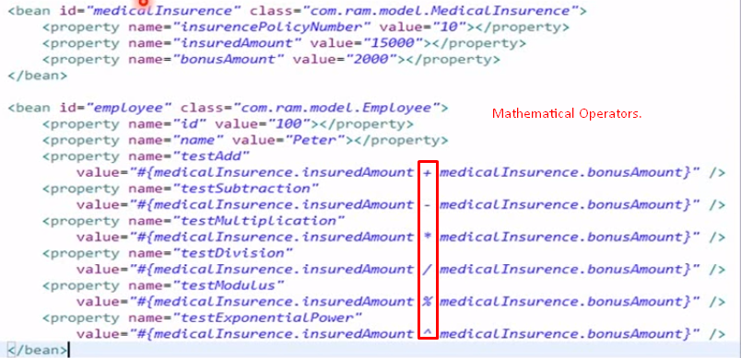

1. Mathematical operators in Spring Expression Language SpEL [Annotation] | Spring Tutorial

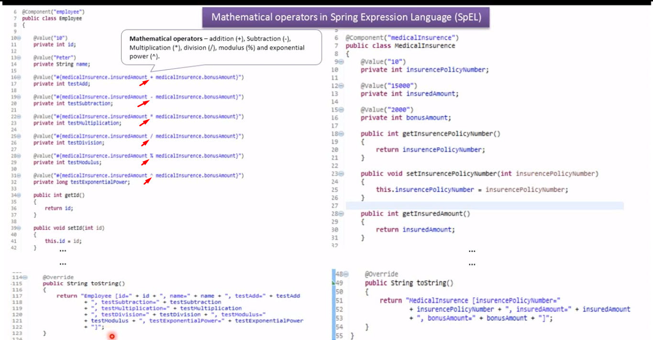

1. Spring Expression Language – Accessing List Collection [XML] | Spring Tutorial

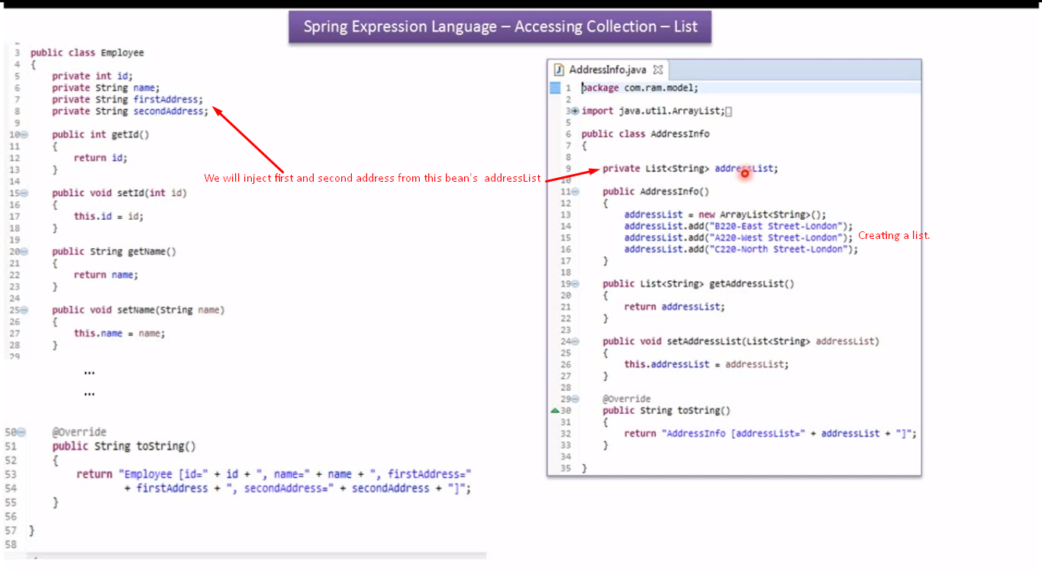 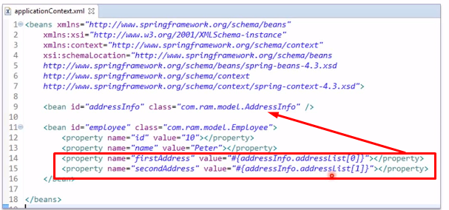

1. Spring Expression Language – Accessing List Collection [Annotation] | Spring Tutorial

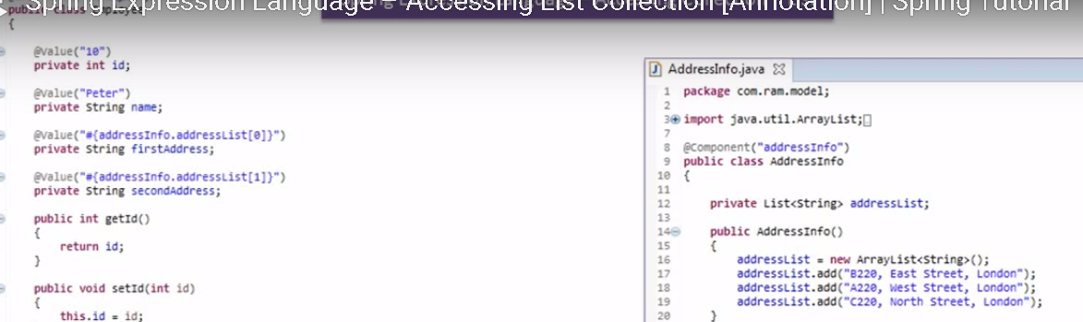

1. Spring Expression Language – Accessing Map[XML] | Spring Tutorial

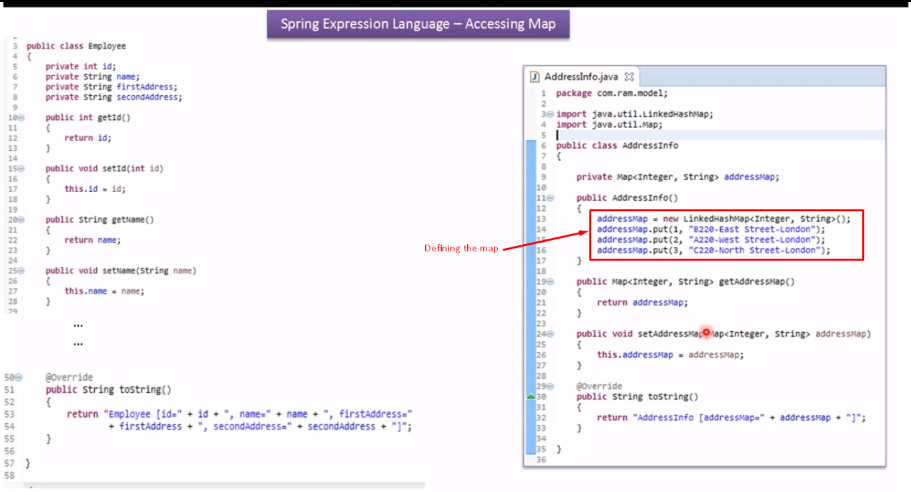 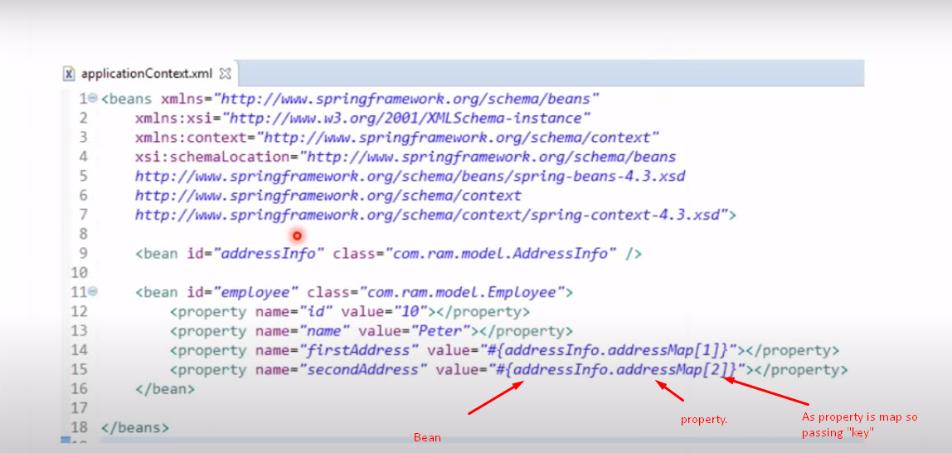

1. Spring Expression Language – Accessing Map[Annotation] | Spring Tutorial

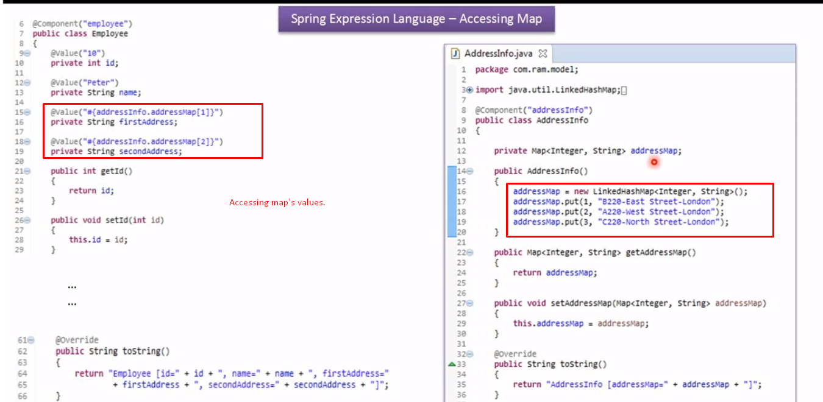

1. Spring Expression Language – Accessing Map[key is String] | Spring Tutorial

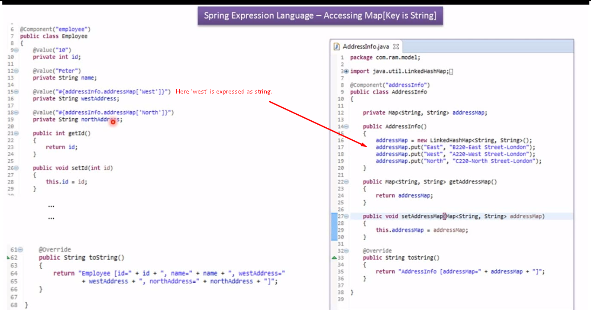

1. The regular expression in Spring Expression Language SpEL [XML] | Spring Tutorial

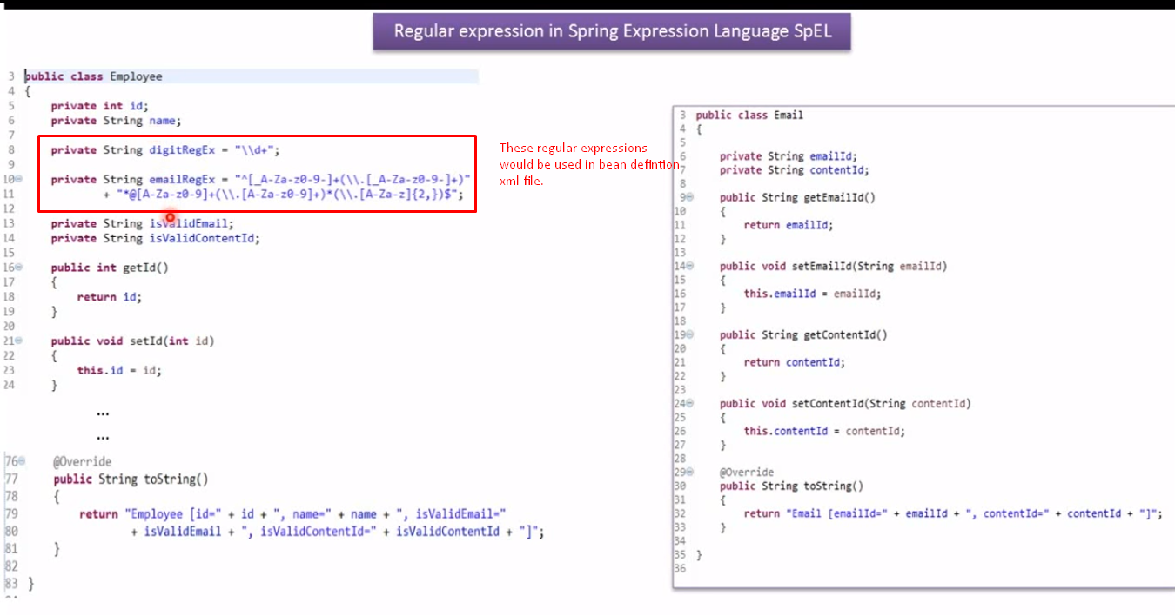 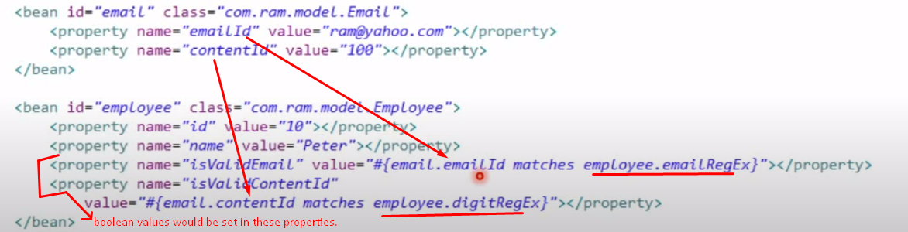

1. The regular expression in Spring Expression Language SpEL [Annotation] | Spring Tutorial

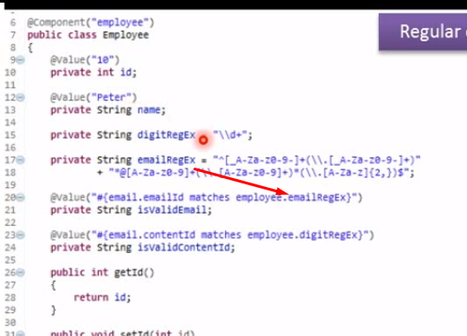

1. Spring Expression Language – Referencing Static Methods and Members [XML] | Spring Tutorial

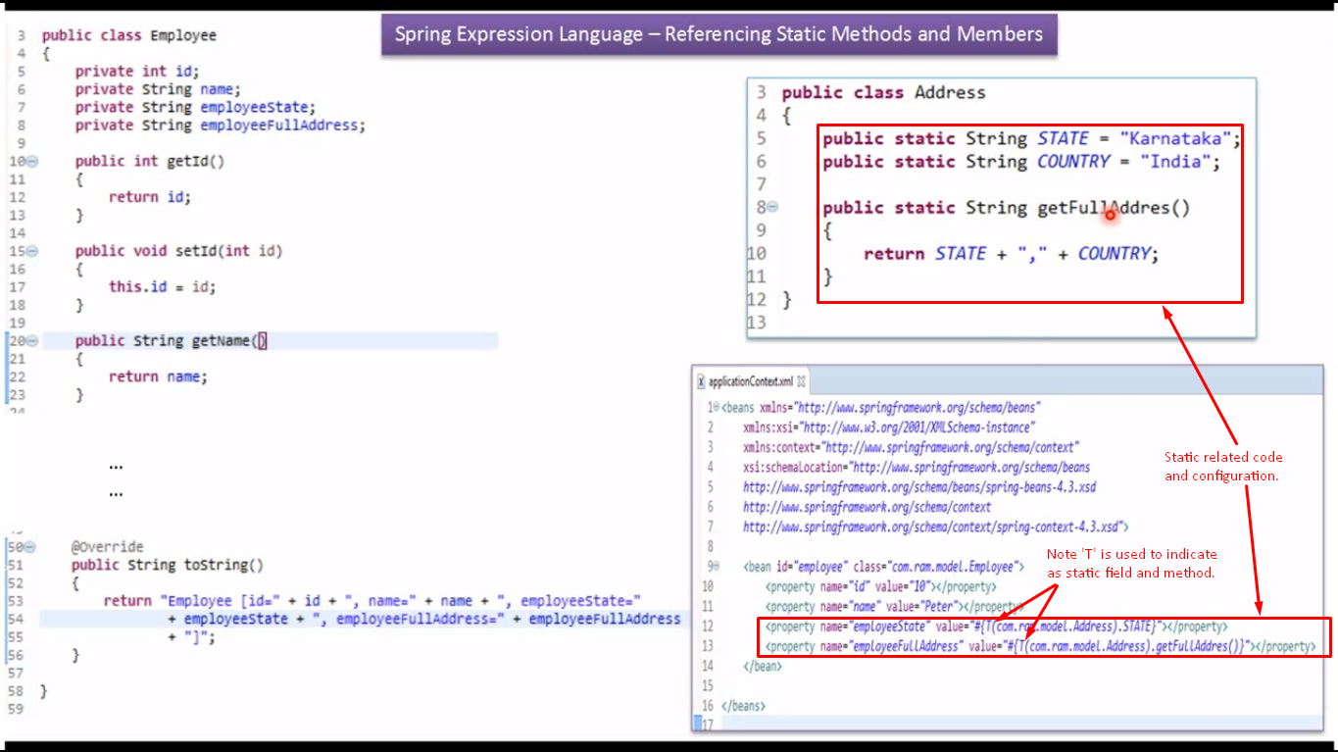

1. Spring Expression Language – Referencing Static Methods and Members [Annotation] | Spring Tutorial

